**USER GUIDE**

VERSION 1.0

**CLAIRE ANGELI ECHIVERRI**

**MARJORIE BONGBONG**

_____________________

WRITERS

**FEBRUARY 23, 2014**

_______________________

DATE WRITTEN

**BLOGGLES USER GUIDE**

This guide will help you through the process of using the blogging application *Bloggles*. Take not of red numbers that appear in the images. These numbers point to items of interest (e.g. buttons you need to click, fields you need to fill out). Other items in the graphics are numbered to serve as clear references.

To get you started, download and install the *Bloggles* Application from the Play Store of your Android device. After installation, the *Bloggles* icon will appear in your home screen.

Tap on the *Bloggles* icon to launch the *Bloggles* application. You will be redirected to the screen below.

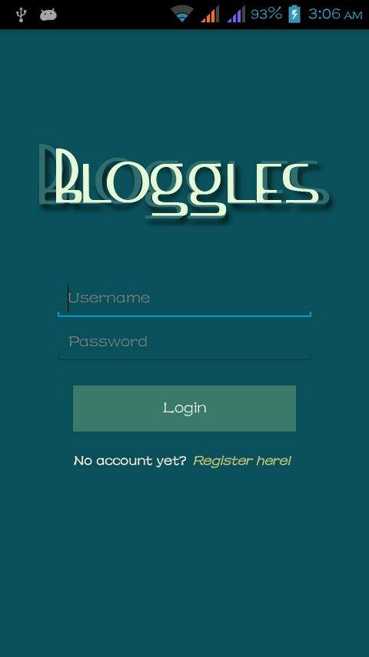

*Figure 1: Log in*

TABLE OF CONTENTS

1. Screens
2. Register 4
3. Log in 5
4. Home 6
5. MyBlog 7
6. Add Post 8
7. View Blog 9
8. User’s Profile 10
9. My Profile 11
10. Followers List 12
11. Following List 13
12. Account Settings 14
13. Blog Settings 15
14. Notes 16
15. Table of Figures 17
16. Table of Revisions  18
17. **Register**

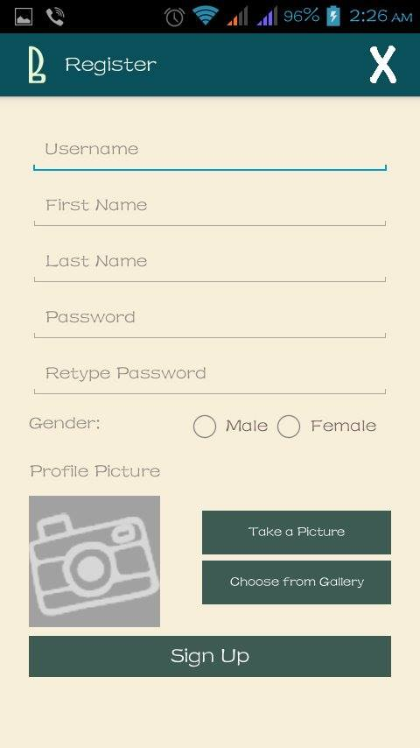

*Figure 2: Register*

If you already have an existing account for *Bloggles*, skip this step and proceed to Log In (Part II).

**To sign up**, tap the “Register here!” link(2) in the *Login* screen (Figure 1). You will be redirected to the *Register* screen (Figure 2). Fill out all the details needed as seen in the screen. All fields are required, except for the profile picture. Details for each field are as follows:

1. The *Username* is the name you will use to log in. It doesn’t have to be your name, just make sure it is something you will never forget. Other users can also search you by this name. The username should not contain any spaces. It accepts numeric values. It only accepts the underscore ( _ ), thus, no other symbols are allowed. It will be displayed in all lowercase characters, thus, entering it in different cases would make no difference. It is also possible that your choice for your username may already be taken. The application will notify you of this case after you have tapped the “Sign Up” button(6).
2. Values for *First Name* and *Last Name* may not necessarily be your real name, but other users can also use these names to search for you. It is also not case-sensitive, and is displayed as sentence-case. It accepts spaces. It does not accept numbers and symbols.
3. The *Password* must be at least 6 characters long, and only accepts alphanumeric characters. This is case-sensitive, so make sure you type in your desired case for each character. It is recommended that numbers and/or different cases for letters are used to formulate the password. Simply retype your desired password for the *Retype Password* field.
4. For *Gender*, tap the right checkbox to tell the application your gender.
5. Your *Profile Picture* can be seen by your followers and by the public. To choose your profile picture, you can either take a picture with your phone by tapping the “Take a picture” button(5a) or choose from your existing images from your mobile phone by tapping the “Choose from Gallery” button (5b). If you don’t want to have a personal profile picture, your picture would be the default profile picture(5). Once you take a picture or choose from the gallery (unless you have cancelled), you cannot go back to having the default profile picture.

Tap the “Sign Up” button(6) to proceed. If you want to cancel signing up, tap the “X” icon(7), where you will be redirected to the Login screen.

1. **Log in**

The *Log in* screen is shown in Figure 1(page 2). This is the first screen that will be displayed upon launching the application (for new users), after you log out, or when you have cancelled signing up.

Enter your username and password on the designated boxes. Make sure there are no spaces before and after your username and password. The password is also sensitive-case so make sure you type in with the correct case. After ensuring you have typed in the correct credentials, tap the “Login” button(1).

1. **Home**

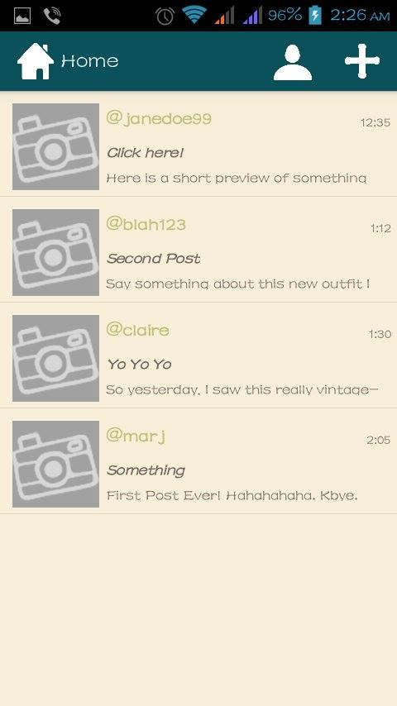

*Figure 3: Home*

On successfully logging in or signing in, you will be redirected to the *Home* screen(Figure 3) where a list of the recent blogs posted by the users you have followed and those set as public1 are displayed. These blogs include the image of the blog user who posted it(1), the author’s username(2), the title of the blog(4), the date when the blog was posted or time, if the blog was posted on the current date(3), and the first few lines of the blog content(5). To **view a blog**, tap the blog entry you want to view. The *View Blog* screen (Figure 6) will be shown. To add **a new post**, tap the “+” icon(7). You will be redirected to the *Add Post* screen(Figure 5a). To **view your profile**, tap the avatar icon(6). You will be directed to the *My Profile* screen(Figure 8).

1. **My Blog**

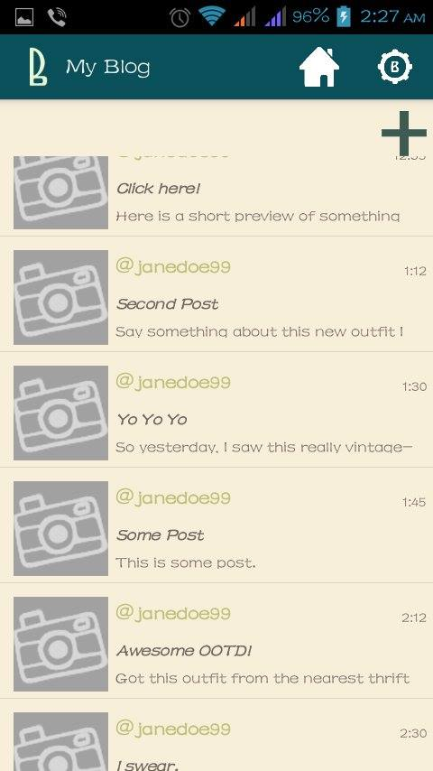

*Figure 4: My Blog*

To **view a list of the blogs you have posted**, view My Profile screen(Figure 8) and tap on the view icon beside the value for Blogs Posted. You will be redirected to the “My Blog” screen(Figure 4). The screen for My Blog looks similar to the Home screen(Figure 3), except that it only displays your blogs, and the image on the left side of each blog entry represents the image posted for that blog. If there is no image for that blog, a default image is shown. **To view a blog**, tap the desired blog entry. **To add a blog**, tap the “+” icon(1). To go back to the *Home* screen, tap the home icon(2). To go to *Blog Settings*, tap the gear icon(3).

1. **Add Post**

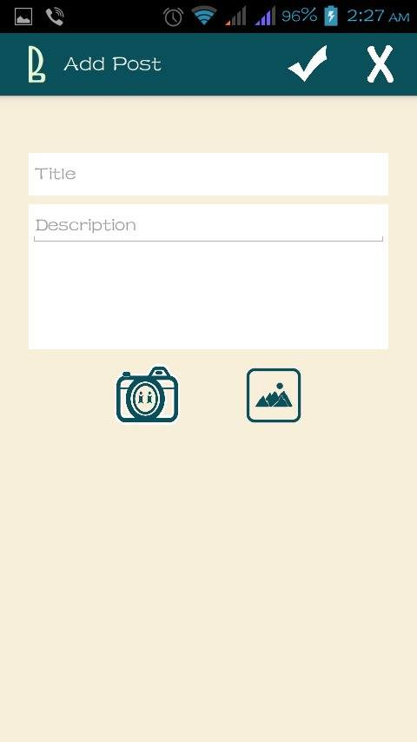

*Figure 5a: Add Post (default)*

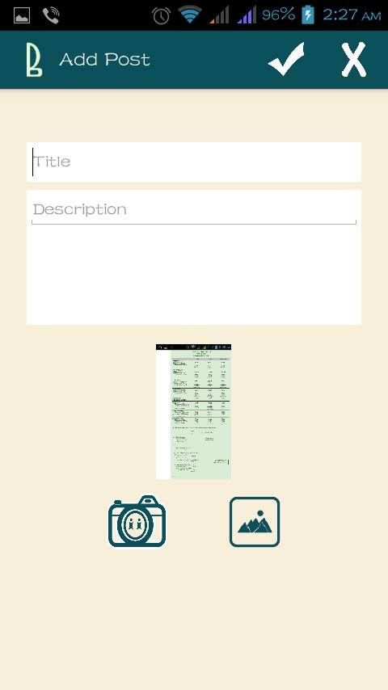

*Figure 5b: Add Post (with image)*

To create a new blog, click the “+” icon found on the upper right part of the “Home” screen(Figure 3) or the “My Blog” screen(Figure 4). The *Add Post* screen(Figure 5a) will be shown.

In this step, you are required to supply the Blog’s Title(1) and Description(2). Both require a minimum of 3 characters, excluding spaces before and after the value entered. Example, when you enter “ a “, it will only be counted as 1 character; whereas if you enter “a a”, it will be counted as 3 characters. For the Title, it is not case-sensitive, and is displayed in sentence-case. To add a photo to your blog, you can either tap the camera icon (3) to take a picture with your phone or tap the gallery icon (4) to choose from your existing pictures. Your taken or chosen picture will show above the aforementioned buttons(5). Tap the check icon(6) to proceed. Tap the “x” icon(7) to cancel adding a post.

1. **View Blog**

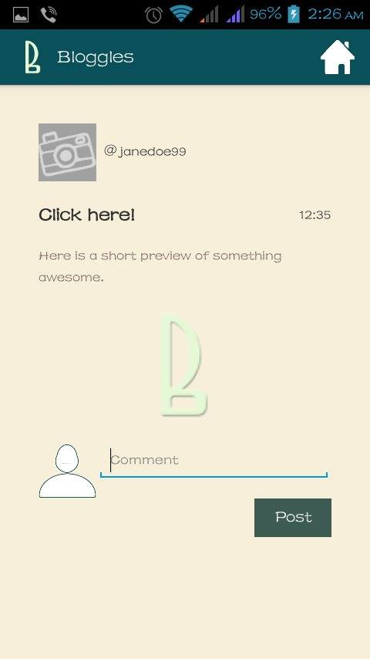

*Figure 6: View Blog*

**To view a blog**, tap on the blog entry you want to view listed in “Home” or “My Blog” screens. You will be redirected to the View Blog screen (Figure 6), where it displays the author’s profile picture, author’s username, image of the blog(6),the title(3), date posted(4), and the blog content(5). Comments6 of the blog are also listed, where you can also **add you own comment** to the blog. Just tap the textbox for comment(8) to do so. You can also see your profile picture before the comment and/or the comment textbox(7). A comment is required to have at least 3 characters long. Tap on the “Post” button(9) to proceed with adding your comment(s). To redirect to the “Home” screen, tap the home button(10).

1. **User’s Profile**

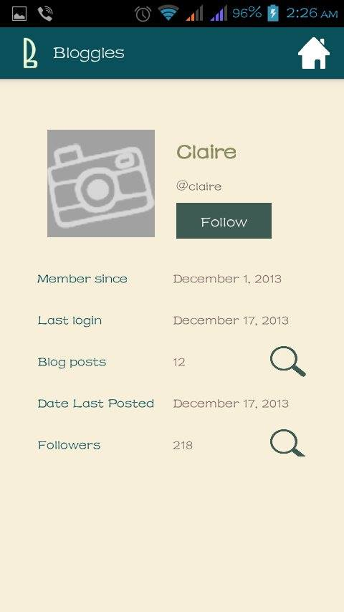

*Figure 7: User’s Profile*

The *User’s Profile* screen displays the viewed user’s profile picture(1), first and last name(2), username(3), the date he registered(5), the date he last logged in(6), the number of blogs he posted(7a), the date he last posted a blog(8), and the number of followers he has(9a). To **view the list of the blogs** he has posted, tap on the view icon(7b) beside the value for *Blog posts.* To **view a list of his followers**, tap on the view icon(9b) beside the value for the number of *Followers*. A button(4) is also found below the viewed user’s username. If you are a follower of this user, the button is labelled “Unfollow”; otherwise, the button is labelled “Follow”. To **follow/unfollow the viewed user**, just tap on this button. To redirect to the *Home* screen, tap the home icon(10).

1. **My Profile**

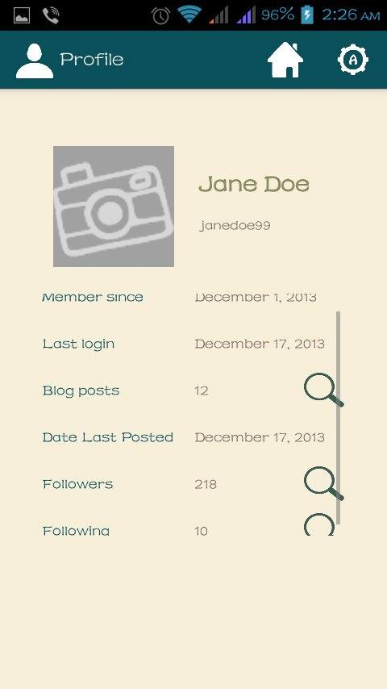

*Figure 8: My Profile*

The *My Profile* screen looks the same as the *User’s Profile* screen, except that it has no follow/unfollow button, and you can view the number of users you are currently following.

The *My Profile* screen displays your profile picture(1), first and last name(2), username(3), the date you registered(4), the date you last logged in(5), the number of blogs you posted(6a), the date you last posted a blog(7), the number of followers you have(8a), and the number of users you are following(9a). To **view your list of the blogs**, tap on the view icon(6b) beside the value for *Blogs posted*. To **view a list of your followers**, tap on the view icon(8b) beside the value for the number of *Followers*. To **view a list of the users you are following**, tap on the view icon (9b) beside the value for the number of users you are *Following.* To redirect to the *Home* screen, tap the home icon(10). To go to *Account Settings*, tap on the gear button(11).

1. **Followers List**

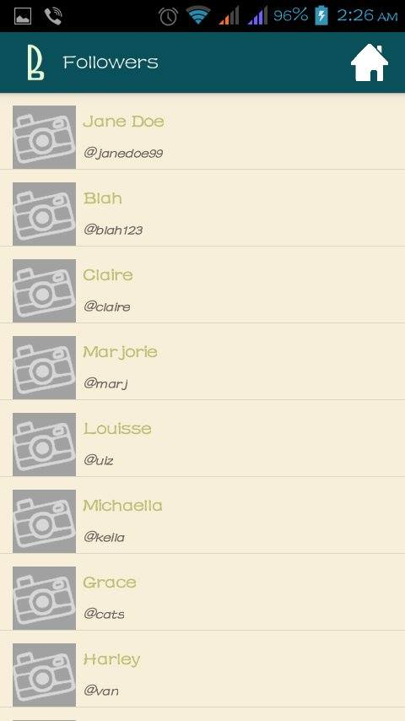

*Figure 9: Followers List*

**To view another user’s or your list of followers**, see *User’s* *Profile or My Profile* respectively. This list displays the complete name(1), username(2), and profile picture(3) of every user entry. Tapping an entry of the list redirects to their profile. To redirect to the *Home* screen, tap the home icon(4).

1. **Following List**

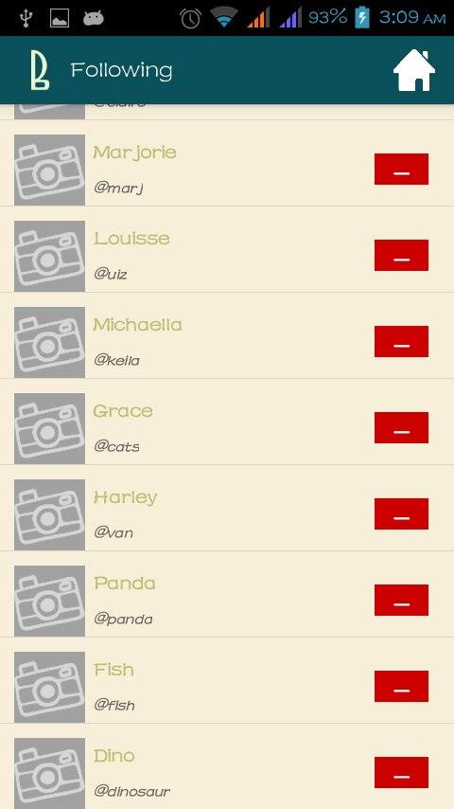

*Figure 10: Following List*

**To view the users you are following**, see *My Profile*. The *Following List* shows the users you are currently following. Similar to the *Followers List*, it shows each user’s profile picture(1), first name and last name(2), and username(3). An “unfollow”button(4) is also displayed at the right side of each entry. Tap this button to unfollow a user. To redirect to the *Home* screen, tap the home icon(5).

**XI. Account Settings**

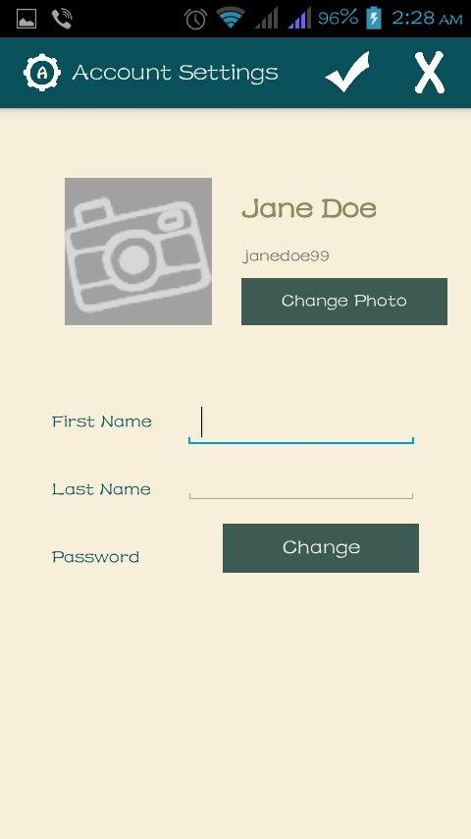

*Figure 11a: Account Settings(default)*

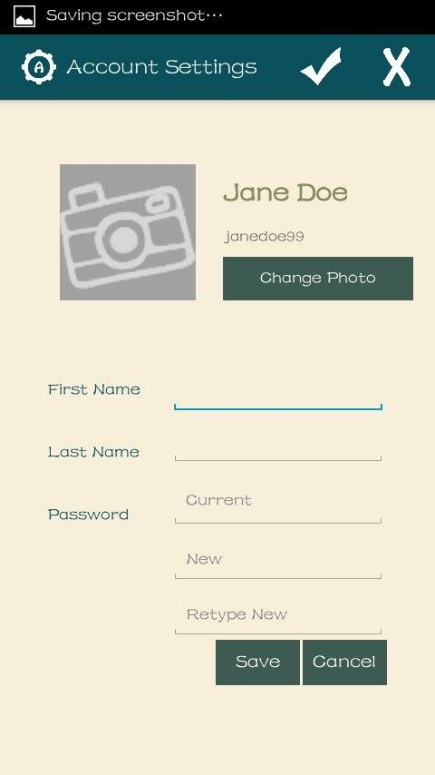

*Figure 11b: Account Settings(change password)*

**To go to Account Settings**, see *My Profile*. The Account Settings screen displays your profile picture(1), first name and last name(2), and your username(3). You are only allowed to change your First Name, Last Name, Password, and Profile Picture. By default, your current First Name and Last Name will be displayed as the values in their corresponding textbox.

* **To change your first name(5) or last name(6)**, tap the corresponding textbox. Values are also validated (see *Register* to check validation). Tap the check icon(13) to save changes. Tap the “x” icon(14) to ignore changes.
* **To** **change the profile picture**, tap the “Change Photo” button(4) below your username, where it lets you choose from your gallery. Your newly chosen picture will be seen in the Profile Picture area(1).
* **To change your password**, tap the “Change” button(7) found beside the Password label, where it shows 3 additional text forms, namely: Current(8), New(9), and Retype New(10)(see *Figure 11b*). Fill out these details. To cancel changing password or to close these 3 forms(which cancels changing the password and clears the forms), tap the Cancel button(12) found at the lower right part of the Change Password form. To save your newly entered password, tap the “Save” button(11). A prompt will appear indicating if changes are successfully saved. If no prompt appears, then there are values not accepted. The value for the current password may not be correct or there may be other validation errors present (see *Register* for validation).

1. **BlogSettings**

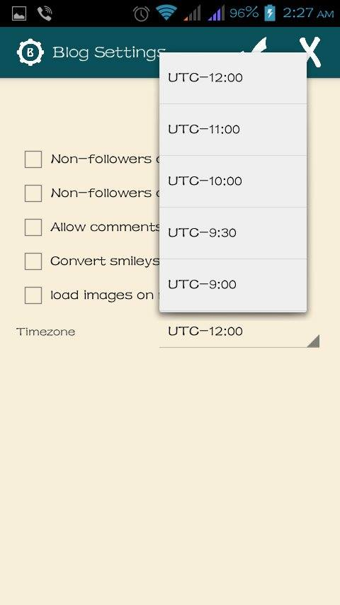

*Figure 12: Blog Settings*

**To change Blog Settings,** see *My Blog*. You will be redirected to the Blog Settings screen(Figure 12).

Blog Settings is where you could set your privacy, e.g. if non-followers could view your profile and/or your blogs. Just check or uncheck the checkbox for your desired choice. A dropdown(1) for your timezone5 is also placed here. To save changes, tap the check icon(2). To cancel changes done, tap the “x” icon(3).

**Notes:**

1 Users may choose to let other users, even non-followers, to view their posts. These posts are referred to as “public” in this document.

2 Users may choose not to let non-followers view their profile.

4 Additional options under Blog Settings may be added later.

5 Timezone is defined as “a geographic region within which the same standard time is used”. It is used to tell the application where you are in order to generate the correct date and time. For a list of supported timezones, see <http://www.timeanddate.com/library/abbreviations/timezones/>

6 Users may choose not to allow comments to their posts/blogs.

**Table of Figures**

1. Login 2
2. Register 4
3. Home 6
4. My Blog 7
5. Add Post 8
   1. Default
   2. With Image
6. View Blog 9
7. User’s Profile 10
8. My Profile 11
9. Followers List 12
10. Following List 13
11. Account Settings 14
    1. Default
    2. Change Password
12. Blog Settings 15

**Table of Revisions**

|  |  |  |
| --- | --- | --- |
| Version | Modifications | Modified By |
| 1.0 | First creation | Echiverri |
| 1.1 | Updated screenshots | Echiverri |